PROJECT TITLE
IMPLEMENT CLIENT SCRIPT &UI POLICY (INCIDENT)

7. Project Documentation Phase
Date: | 29.09.2026
Team ID: | SWTID-2026-2139
Project Name: | Implement Client Script & UI Policy (Incident)
Project team | Team Leader : DHIVAKAR M  Team member : DINESH KUMAR V  Team member : KOWSHICK N  Team member : MOHAMED NIYAS S

7.1 Introduction
The Project Documentation Phase is the stage where all the activities performed during the project are organized and recorded in a systematic manner.
The project “Implement Client Script & UI Policy (Incident)” was developed using the ServiceNow platform. The documentation records the project idea, requirements, design, development, testing, and final outcome.
Proper documentation helps the team to clearly present the project work and provides a reference for future maintenance and improvements.

7.2 Purpose of Documentation
The main purposes of project documentation are:
- To maintain a complete record of the project.
- To explain the project objectives and requirements.
- To record the development activities.
- To document the Client Script and UI Policy implementation.
- To provide evidence through screenshots.
- To record the testing process and results.
- To make the project easy to understand and maintain.
- To support the final project submission and demonstration.

7.3 Documentation Structure
The project documentation is organized into the following eight phases:

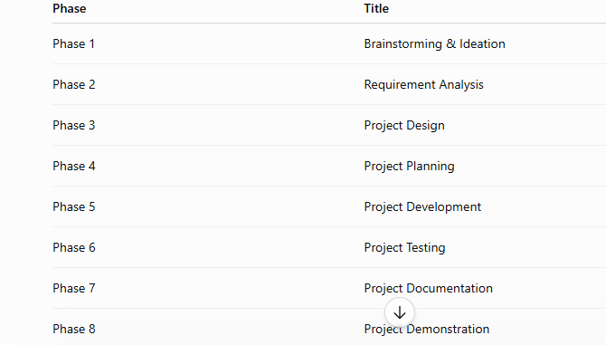
Each phase describes the activities completed during the corresponding stage of the project.

7.4 Project Documentation Content
The documentation contains the important information required to understand the complete project.
It includes:
- Project introduction and objectives.
- Problems identified in the Incident form.
- Functional and non-functional requirements.
- Project design and planning.
- Client Script implementation.
- UI Policy implementation.
- Testing procedures and results.
- Screenshots of development and testing.
- Final project outcome.
- GitHub repository information.
- Project demonstration information.

7.5 Development Documentation
The development activities were recorded to show how the project was implemented in ServiceNow.
The main development activities included:
- Opening the ServiceNow Incident module.
- Identifying the required Incident fields.
- Creating the Client Script.
- Configuring the Client Script.
- Adding the required script logic.
- Creating the UI Policy.
- Defining the UI Policy condition.
- Creating the UI Policy Action.
- Saving and verifying the configuration.
- Opening the Incident form to check the developed functionality.
Client Scripts and UI Policies are client-side features used to control and manage form behavior in ServiceNow.

.6 Testing Documentation
After completing the development, the Incident form was tested to verify whether the implemented functionality worked as expected.
The testing included:
- Opening the Incident form.
- Entering different values.
- Changing the Impact and Urgency values.
- Checking the Priority value.
- Checking mandatory field behavior.
- Checking validation messages.
- Checking Client Script functionality.
- Checking UI Policy functionality.
- Verifying the final Incident form.

7.7 Documentation of Final Result
The final result of the project was documented after completing the development and testing activities.
During testing, the Incident form displayed the required behavior based on the configured conditions. For example, the form showed:
- Impact = 1 - High
- Urgency = 1 - High
- Priority = 1 - Critical
- Assignment Group = CAB Approval
- Assigned To = Howard Johnson
A message was also displayed indicating that the urgency was set to High for a High impact incident.
This final state was recorded as evidence of the completed project testing.

7.8 GitHub and Project Files
The project documentation and related files are maintained in the project GitHub repository.
The repository contains the project materials organized according to the required project phases. The repository link is included in the final submission.
The project files and documentation should be kept organized so that the teacher and team members can easily access the required information.

7.9 Document Quality and Maintenance
The documentation is prepared in a clear and organized format.
The following points were considered:
- Consistent headings and formatting.
- Proper figure numbers and captions.
- Clear explanation of each project phase.
- Relevant screenshots.
- Correct sequence of project activities.
- Proper organization of project files.
- Easy readability and understanding.
The documentation can also be used as a reference if the Client Script or UI Policy needs to be modified in the future.

7.10 Final Documentation Checklist
Before submitting the project, the team verifies that:
- All eight phases are included.
- Project details are provided.
- Development screenshots are included.
- Testing screenshots are included.
- Test results are documented.
- GitHub repository link is provided.
- Project demonstration information is provided.
- All required project files are organized.
- The final document is checked for formatting and errors.

7.11 Conclusion
The Project Documentation Phase brings together the complete work performed during the project. It records the requirements, design, development, testing, results, and supporting evidence in a structured manner.
The documentation provides a clear record of the implementation of Client Script and UI Policy in the ServiceNow Incident module and supports the final project submission and demonstration.

